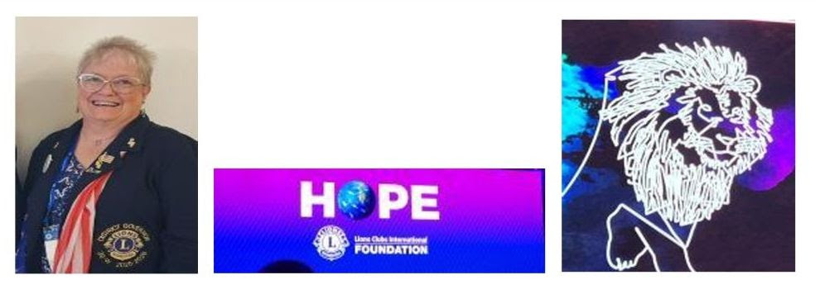

Lions of 39 W. You are Grandiose!!
You have done us proud. We are in the + for membership and we have new LEOs.
MD 39 Convention = our International Director was Lion David Wentworth and he was a real RingLeader!!

PCC Betty and her LCIF Team have done a great job raising money. They presented 3 Melvin Jones awards from Heart of a Lion. Weiser club has given to most per member to LCIF. We all need to consider signing up for monthly amounts. Area H LCIF, Cliff Hart reported that area H is just a few $1000 short of reaching our $900,000 goal.
Envision had a fantastic training to set goals and help everyone on the Board to work together. Their remodel is complete with new area for sales, new equipment for processing corneas, so they no longer have to ship them away. They also have a system to donate monthly.
Camp Hodia is helping children ages 4th grade to 17 and their families, it costs $2,500.00 for them to attend. The camps work on Time, Treasure and Talent to help the kids have more confidence and they discover they are not the only one with diabetes.
Special Olympics not only focuses on athletics, they work on the health needs of every athlete as well. They train in 15 sports and Lions have been a partner since 2001. Special Olympics has 3,500 athletes in Idaho. They are always looking for volunteers. WE CAN HELP.
Leader Dog paid us a visit. Jess Vanderboom came and brought a student, Kayla, with her dog, Tellie. They made a great presentation. They have room for 150 dogs and 30 people plus the staff. They have continuous training with summer camps. They teach white cane and dog training. 87 years ago Lions created Leader Dog and we need to continue to support them.
Scouting: Idaho is the 4th highest in suicide and our youth need mentorship. Their Motto is “Do Your Best” and their first level is Lion. Help with a pack already formed or start a new one as an after-school program. Youth of today need our help.

Environmental learning: No Electronics should ever go into the land fill.
Best Buy and other office supply stores will take monitors, TVs, and printers. None of these should ever go into the trash. Green Square of Boise will take all computers, laptops, I pads, cell phones, cameras, games, headphones, and all cords. They pay a small amount for what you deliver to them. Contact Tobhiyah at 208-597-0997 or tobhiuah@greensquared.com.
The vote was really close, and we are going back to Sun Valley next year. The zooming seemed to work well and the voting online did well.
Thank you to Parma, Adrian, and Weiser for a wonderful time at Charter Parties and meetings.
MD 39 is putting on monthly trainings. Lion Joyce Saunders and Lion Lynne Burks = June is New Officers.
“Just Ask” to get new members!!
District Governor Elect Lisa Gier


As we look ahead to an exciting new Lions year, I want to congratulate District Governor Peggy and thank her for her leadership and service to our district this past year.
I am also looking forward to the opportunity to attend the 2026 Lions Clubs International Convention in Hong Kong. Conventions like this are a great chance to learn new ideas, connect with Lions from around the world, and bring back resources and inspiration that can benefit our clubs and communities.
As I prepare for the convention, I would love to hear from members across the district:
What would you like me to learn more about or bring back to share with you?

Whether it is:
- Education and leadership development
- Membership and service ideas
- Professional development
- Networking connections
- Club engagement strategies
- New programs or successful projects from other districts
Please let me know what interests you most.
My goal is to make the most of this experience and bring home ideas, tools, and connections that will be most helpful to the amazing leaders and members in our district.
Thank you for all you do, and I look forward to learning and growing together in the year ahead.
Kindly,
Lisa

Helpful LCIF Donation Timeline Information
Please follow the timeline below to help ensure all donations and recognition requests are processed within the current Lion Year:
- Mailed donations and/or recognition requests must arrive at the Carol Stream address no later than Monday, June 15, 2026:
Lions Clubs International Foundation
Department 4547
Carol Stream, IL 60122-4547 USA
- Donations and/or recognition equests received after June 15, 2026 should be sent directly to the Oak Brook office, Attention: Donor Services:
Lions International
300 W 22nd St
Oak Brook, IL 60523-8842
Online donations should be completed by Thursday, June 26, 2026.
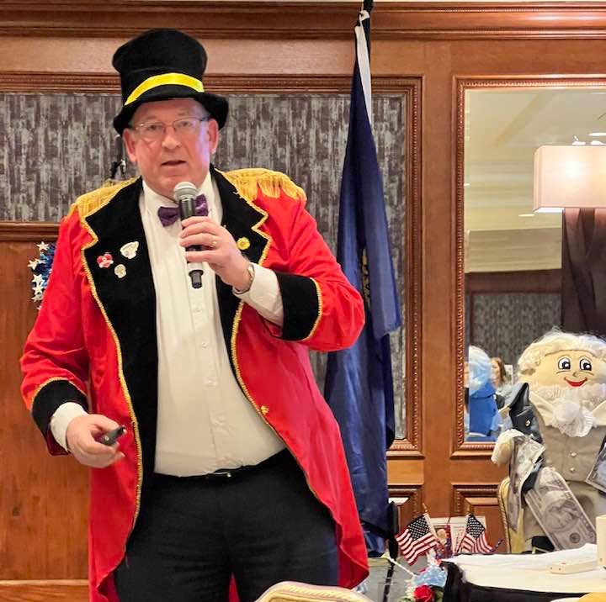

International Director David Wentworth ( Omaha Nebraska) at MD39 Convention extolling the message of the movie “The Greatest Show On Earth “.. equality, following dreams and service “..His motto he repeats daily “It’s a GREAT day to be a LION “…Service to humanity is the greatest work in life … He is a baseball player and he hit a grand slam at our convention…motivational, informative, inspirational , personable and entertaining…We are fortunate to have him on the LCI board… and for one more year.

